

PC Peripheral Store

**Aaron Lynch**

**N00182364**

Year 2 2019-20

DL836 BSc (Hons) in Creative Computing

Table of Contents

1 Introduction 1

2 Business Concept 1

2.1 Introduction 1

2.2 Business model 1

2.3 Market Research 1

2.4 Other optional points go here 1

3 Website Design 2

3.1 Introduction 2

3.2 Design Research 2

3.3 Design Process. 2

3.4 Design Framework 3

4 Database Design 3

4.1 Introduction 3

4.2 ERD Diagram 3

4.3 Additional information 3

5 Implementation 4

5.1 Introduction 4

5.2 PHP 4

5.3 Javascript 4

5.4 Bootstrap 4

5.5 Cascading Stylesheets 4

5.6 Database Design 4

6 Testing & Results 5

6.1 Introduction 5

6.2 Discussion of Functional Testing Results 6

7 Project Management 6

7.1 Discussion of use of Github for Software Project. 6

8 Reflection 6

8.1 Assessment of your learning. 6

9 References 8

# Introduction

For my website I decided that I wanted to create a PC peripherals website that predominantly focused on high end mice, keyboards and headsets aimed towards the gaming demographic. To begin with I looked at various other large online retailers who sell computer parts such as newegg, amazon and currys. These are huge sites that although similar to what i wanted to achieve i also looked into smaller more specialised websites like Origin PC and wasdKeyboards who make custom PC’s and keyboards.

Upon sketching out a design of my general concept, next i built a wireframe of my website then finally moved to having a finished concept in photoshop. From here i began deciding what tables i needed to store my shops data and how that would tie into my design, i then refactored the given database to fit my needs and moved to building both an initial HTML and CSS build of my site hardcoded and the a version using PHP linking the Product data from the database.

# Business Concept

## Introduction

My idea was to create a site that focused on the PC peripheral market specifically focusing on high end gaming mice,custom keyboards and headsets. While many large online shops stock PC peripherals they are generally lost in with many other aspects of the pc market such as PC components and general tech. My site would focus on bringing an easy to view shop focused on delivering only high end peripherals.

## Business model

The main income for the site would be through sales and brand sponsorship for banner advertisements run on the site. Another source of income would come from brand sponsorship for search priority on the site showing their products first. These sponships are key as non-product related advertisements would not be allowed on the site as they would take from the clean premium feel of the site.

A final source of income would come from the sale of exclusive limited run stock such as professional player lines.

## Market Research

My market research consisted of looking mostly at other more bespoke online shops for gaming products such as custom gaming pc builds or custom keyboard sites and seeing how they approach customer acquisition and what brands are most popular. It is clear from market research of other sites that many gamers are willing to spend a lot on their PC peripherals but it is then common for them to not need any again for some time so it is very important to draw in new customers or encourage upgrading through deals and bundles in your shop.

# Website Design

## Introduction

My website predominantly focuses on high end mice, keyboards and headsets aimed towards the gaming demographic. My main concern with my design was to avoid the cluttered look that many of the larger online stores have where there are menus on top of menus of sections for every type of pc part, peripheral, laptop/phone peripherals etc.

Trimming my product range down to mice, keyboards and headsets allows me to slimline the design of my website and make it easy to navigate.

## Design Research

I originally looked at large websites like amazon’s tech section or newegg but found their designs to be cluttered and clunky to navigate, so i then moved to sites that offer a more personal experience with custom builds. When looking at these sites I noticed that the designs of the sites were much simpler. While they contained less content they were much better at displaying and selling the content they did focus on.

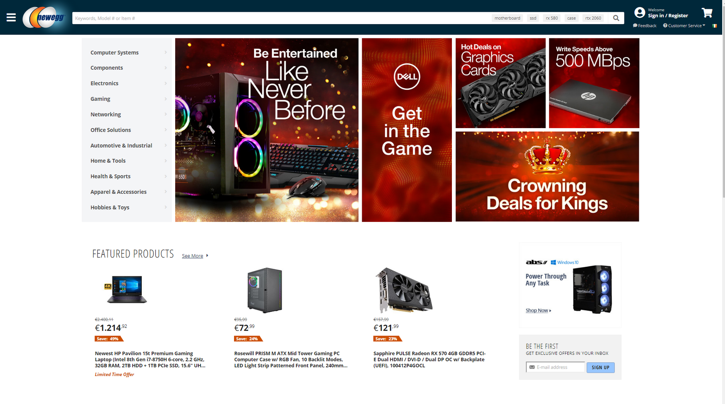

Above you can see Newegg's large wide container-fluid style.

## Design Process.

Include and describe your design decisions. Show evidence of iteration in your process. Include mood-board, sketches and final design output.

I began after looking at various sites and deciding what sort of colour palette I wanted to go with. I finished on the idea of keeping it clean and simple and went with a colour palette of white to black with an array of grey shades in between to tie it together. This would help me achieve a clean site with strong lines of contrast to help the header or sections stand out from the rest of the site.

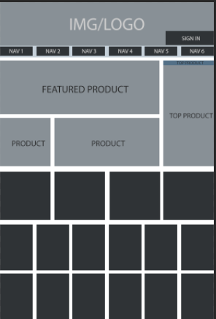

When looking at many larger sites I noticed they went for a container-fluid full page style which while great for stylish homepages lacked organisation when actually searching through products. For this reason I decided to keep my main body of content in a 12 column grid to keep the content centered on my page so as not to have information fighting for the users eye from all corners of the site. The nav and footer would be the only elements of the website that would fill the width of the page.

Following this i decided on my typography style and size range for the site so the site always maintains good readability and is not a strain for the user to see the information on the page. I decided to maintain one font throughout the site as all that is required is to have a good clean font to help sell products and nothing that would detract attention from the products themselves.

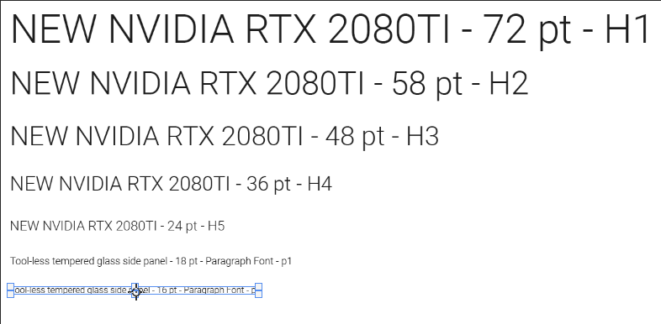

Finally i moved to actually building a HTML and CSS hardcoded version of the site to test my design and decide how the sites divs should be constructed to ensure my plan for a clean and simple aesthetic was achieved. I began first building my Nav and footer as these where the two aspects of my site which used the full width of the screen and would hold the look of the site. I decided on having my nav stick to top so as to have access to it at anytime which i believe to be important when on a shopping website to always ensure fast navigation to different sections and the users shopping basket.

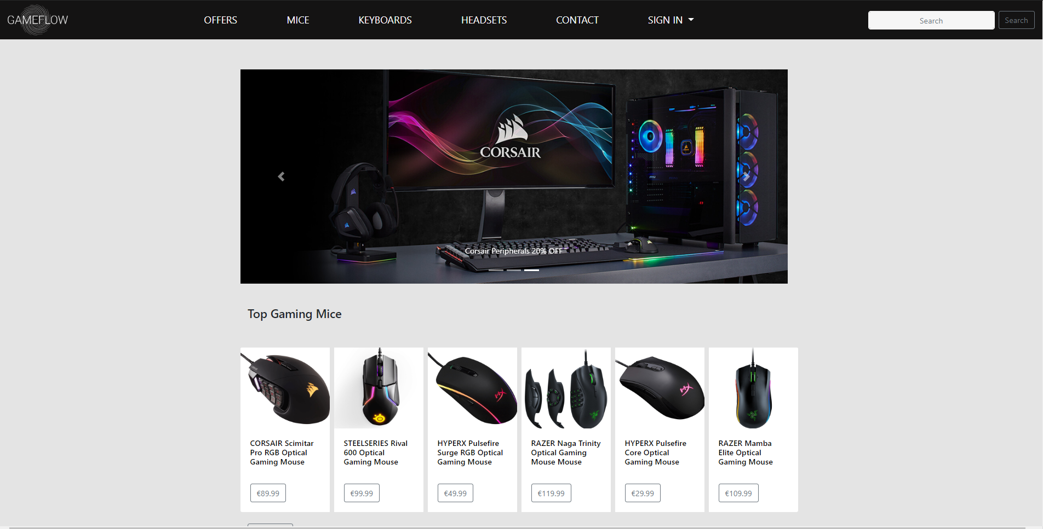

Above final HTML Design for main Products Page

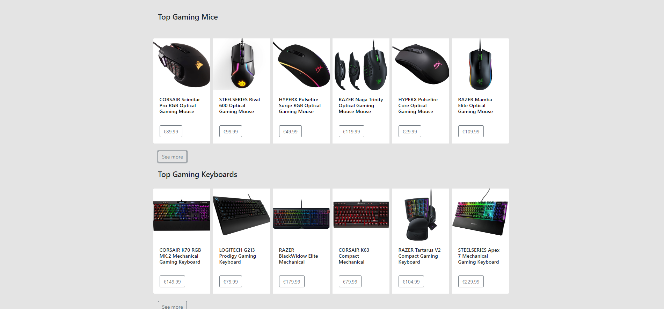

Product Card design in HTML & CSS

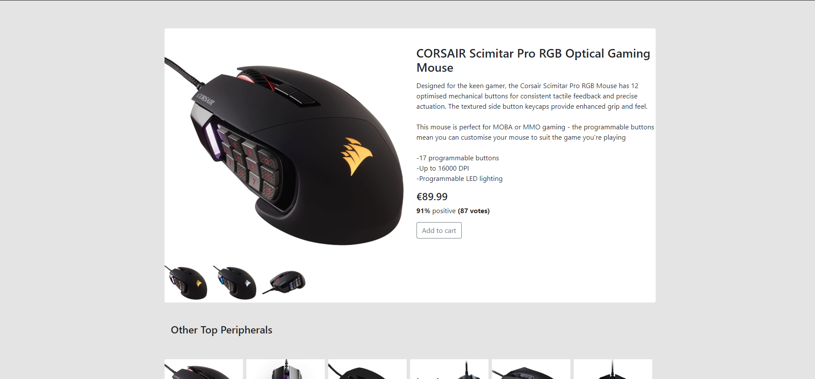

Product Description and viewing page HTML & CSS

The last thing I created for my Design was a sign in and new sign up page, I decided to keep them brief and not clutter there pages up to much just keeping my sites main banner add running and then all the information of the form for the user to sign in or complete a new sign up form.

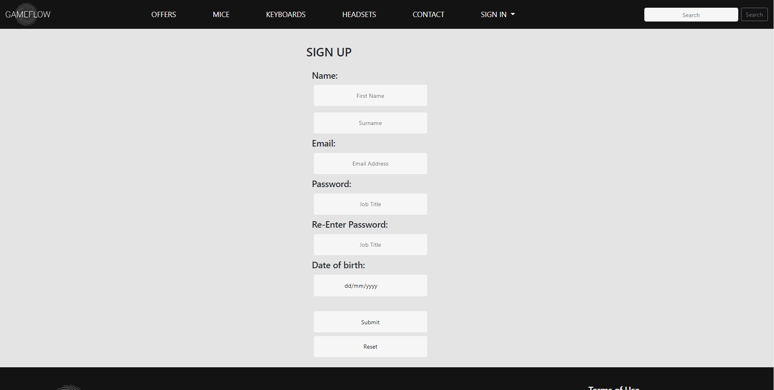

Sign Up Form

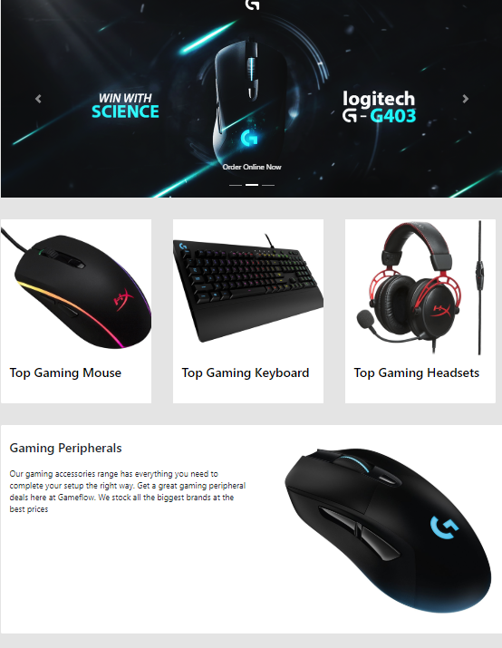

Homepage Hardcode Card design.

## Design Framework

Below is one of the later versions of my design in Photoshop before I moved to coding up a hardcode version of my site through HTML and CSS. I would regularly refer back to this as a guide to help me in my design decisions and keep the end product as close to my vision as possible.

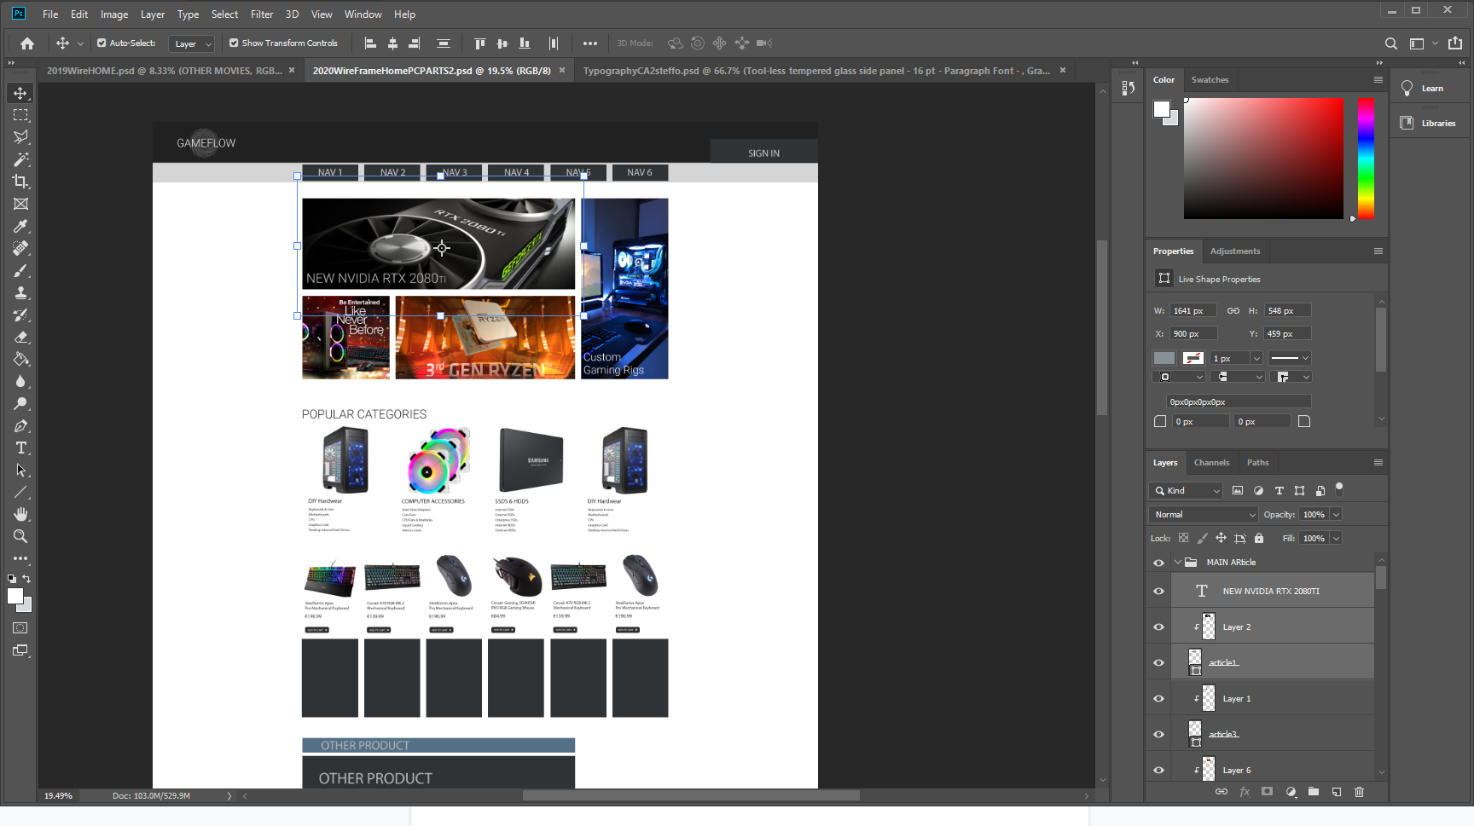

Design in Photoshop.

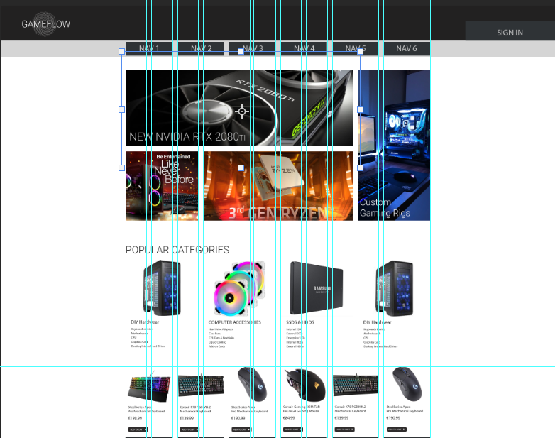

Wireframe guide for site layout and on right a look at my 12 column grid system

I found it very useful to have these wireframes and pre planned grids as it made it very easy when building the website in HTML & CSS to place things and form my divs how i need them to be in order to present my content in the way i had planned. This also helped when using the Bootstrap 4 framework as it contains many great tools for creating cards and various other items. This combined with a pre-planned site using Bootstrap’s 12 col grid led to easy application of the design.

# Database Design

## Introduction

Describe the database design of your web application. This is the first paragraph.

## ERD Diagram

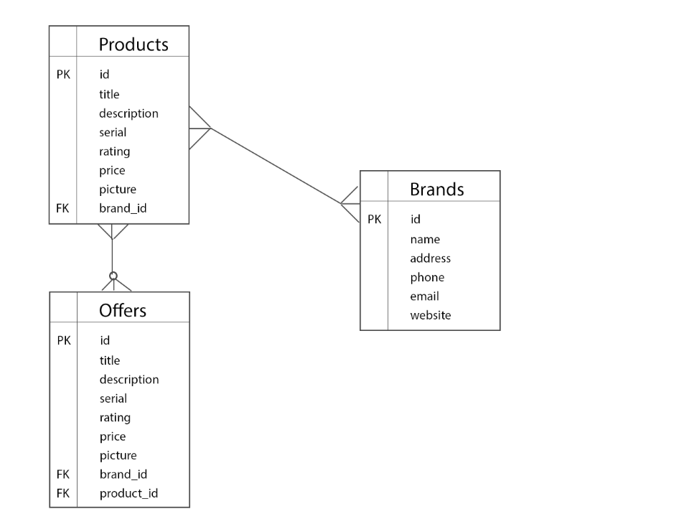

# Implementation

## Introduction

For the implementation of my design my goal was to have php dynamically fill out organised divs containing product information from the database. This would easily display all available products in the database in an organised fashion and would not require the hardcoding of divs so as to fit in the right position. Instead the php would loop the Div element creating my product displays. I also needed to refactor the database to be used with my data and have the Create, Read, Update and delete all functioning correctly. It was important that it was very easy to add a product and its information to the database and then to have that quickly added to the main view of all products and be in the right position too.

The advantage to this was it kept a consistent and easy to read format for all the products for sale and would accurately display all products from the database in a section. I could then repeat the process in a second set of divs to show all products on offer. This would be advantageous, as when you update or add new products to the sale offers section the php will dynamically change and add in or remove offers as needed instead of having to hardcode them in.

## PHP

Describe how the following operations are achieved through PHP:

* On my backend I have my product.php file which is used in the creation of new product objects within the database, this is used when product_create.php is called to create a new product entry to the database. The php is used to pass the data from the form to the database and then also used to view all and pull the data from the database. The viewing of individual items was achieved by matching the selected item on the view alls ID to the table in the database and pulling all of that data in for the new product display page.
* For the front end application of this the user would just see all items present in the database displayed to them broken up into divs of col-2 making six per row taken all from the products table.

## Javascript

Describe which functionality of your web application was implemented in Javascript.

## Bootstrap

For me I found Bootstrap 4’s grid system to be extremely useful in forming the layout of my site, I used a mixture of containers/container-fluids along with their 12 col grid system. I regularly used their card class to create my base div card to then insert my php into and create my product display. Other Bootstrap elements I found useful was their carousel item to help in creating a banner advertisement, nav creation and simple but unique buttons. A collapse class from Bootstrap allowed me to contain an Admin panel within the main sit out of the users view.

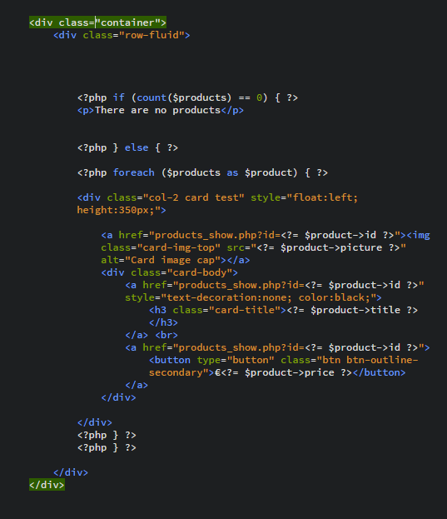

Main Product card design using PHP and Bootstrap

## Cascading Stylesheets

While Bootstrap can provide much help with forming structure to your website and useful object most of the actual styling of the page was handled through my style.css. Here I controlled set things like background colours and the product cards colour to stand off from the background. Font management was handled in here. Any custom sizing classes or colour changes need to make would be put into a class in the CSS and the called in the php document

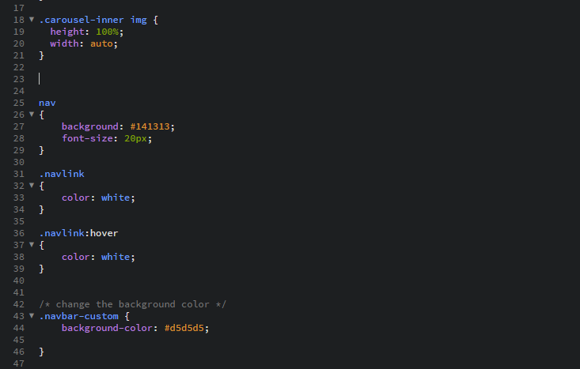

Example of some altering of Bootstrap CSS as well as sizing.

## Database Design

Describe your Database implementation using the following pointers:

• Keeping Referential integrity in mind my database should look to keep all products only if there is a matching brand_id to the brand table. If the brand does not exist in store anymore than neither should any product sold by that brand.

• For my database to connect to the database it uses a connection.php file from my classes folder, here it would point to the correct database. This was hosted locally on xampp

o A SELECT query with at least one WHERE condition

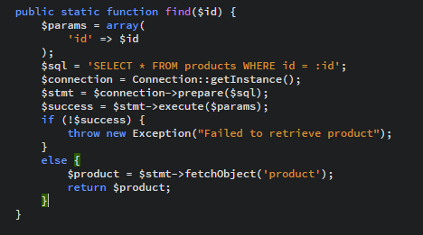

Above you can see the find by ID function from my Product.php ,this was used to SELECT

all data from the products table WHERE the id matches the passed through ID.

o An INSERT command

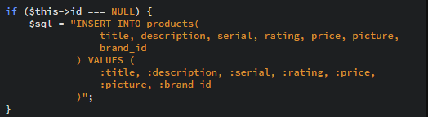

Here is an INSERT command used when creating new entries into the database. This takes

the past in values as creates a new object in the database.

o An UPDATE command with at least one WHERE condition

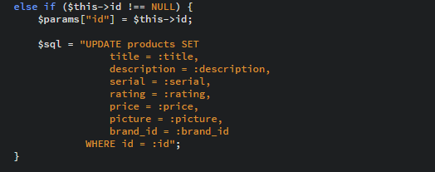

# Testing & Results

## Introduction

I did not start performing any testing until i was deep into building my early site hardcoded in HTML & CSS once i had my main layouts decided on i did begin testing my div setups to ensure that when the php was used in the site that everything would sit where needed.

My next round of testing began when i created the php version of the site and connected it up to the database. This was to ensure that data was indeed being read correctly from the database and that it was also being inserted correctly so as not to cause problems in the future. If i ran into any long running bug i would write it in a comment so as to know that it needed to still be solved.

|  |  |  |  |  |  |
| --- | --- | --- | --- | --- | --- |
| Test No | Description of test case | Input | Expected Output | Actual Output | Comment |
| 1 | Carousel stretching | images | original format | stretched images | card heights not set |
| 2 | Image duplicate Test | same Img | update data keep same image | Will not change content due to same image | Check database |
| 3 | 6 card grid not sitting correctly next row skips first 2 card | 12 cards over 2 rows of 6 | two 6 card rows | 1 row of 6  1 row of 4  1 row of 2 | RESOLVED  ended up being single img height |

## Discussion of Functional Testing Results

Most bugs I encountered were solved quickly as they mainly involve content not sitting where it was intended in the grid so it was just a case of breaking it down and inspecting the site to see what the problem was. If any issues arose with the php side it was generally a problem with placement of opening and closing of php in the html code so this was generally my first thing to check.

# Project Management

## Discussion of use of Github for Software Project.

Describe your experience of using Github for version control and project management.

I personally found Github to be useful for if you have to work on a project with a large group but for me personally i had many issues with getting into my account and with pushing data to my github. I found other cloud storage to be personally faster and more convenient but found the organisation of github much more useful to track project progress.

# Reflection

## Assessment of your learning.

From this Continuous Assessment i have most definitely pushed my skills in design further and learned much more about delivering more streamlined and clean designs focused on providing an easy experience as it is very clear that when the design of a website is clunky and cluttered you generally lose that customer in the first few seconds. Using bootstrap was also a great skill to learn as it showed how useful a framework like that can be but also taught me how to adapt the useful parts of these frameworks and customise them for my own requirements.

I also gained a better knowledge in how to incorporate my hardcoded designs and make them dynamic by connecting them to a database. This showed me how to integrate both HTML, CSS and PHP to create a complete and professional dynamic website.

For me i feel that i could now vastly expand on the amount of product tables categories helping me then to provide better searching criteria. This would also help me further organise the front sales page to create different card lists based on various categories. I also would have liked to implement a login so as to have my admin function only viewable by somebody logged in as an admin.

I definetly learned that my time delegation on the project could have been much better managed and it is easy to get distracted during the design phase. In future i would have jumped into early hardcode versions earlier so as to get a better idea how my database and site design will link up.

# References

The Department of Technology and Psychology in IADT uses APA referencing style.

Use alphabetical order for your references.

This site gives details about how to cite websites using APA:

https://www.wikihow.com/Cite-a-Website-in-APA

The following is a useful site for creating citations for APA for websites.

<http://www.citationmachine.net/apa/cite-a-website>

You can also use the Referencing tab within Microsoft Word to enter reference information manually. Word then creates an APA style reference.